Part 6:  
Sharing Screen on/Off

* getDisplayMedia () is useful in capturing the screen\
* Now here till now if our video is on and if we then click on the presentNow option then screen streaming will start at that time our video goes down but the icon will still show video is on so now we need to change it
* Now in VideoProcess function we will add
* 

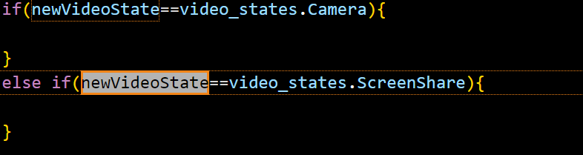

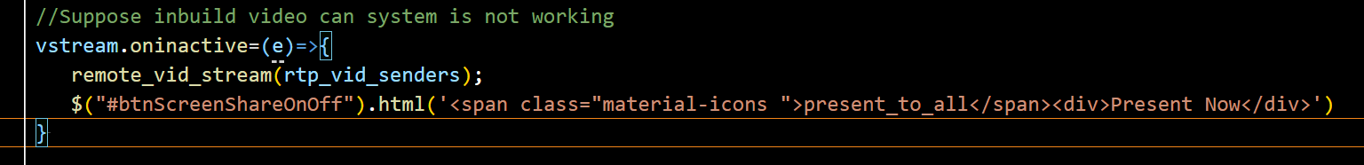

Part2 Disconnect Users

* So now if the users click on end call then he will leave the room and other users also get to know about it
* Now go to newserver.js
* 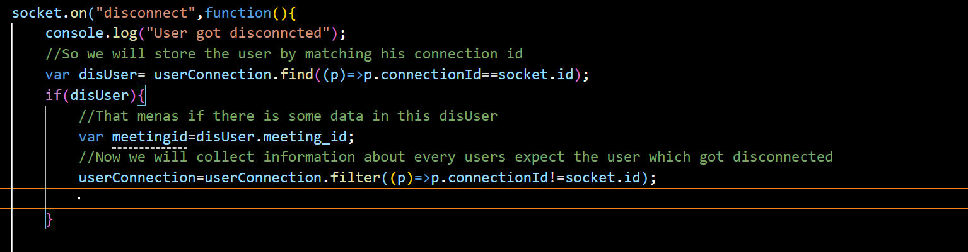

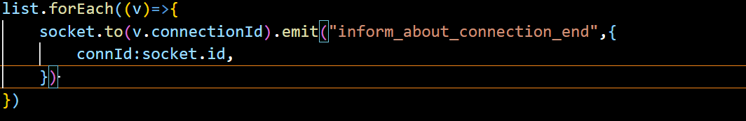

* In app.js
* 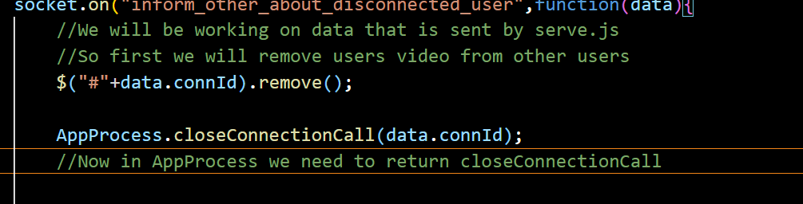

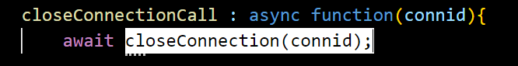

OutPut

